Objective
This document describes overarching management objectives and principles that guide forest management over the entire Ents forest estate.
It has regard for:
- Social/cultural, natural resources, environmental and economic values
- Silvicultural and harvest/haulage systems
- Risk management procedures and
- Monitoring of these important matters
This umbrella document references other property-level or operation-specific plans and procedures which should be read separately.

Scope
 | The entire Ents Forestry managed estate. This estate is spread from Bunbury to Albany in south-west Western Australia. It is approximately 18,000 ha in total.

Management objectives
Economic objectives | Ents Forestry is committed to managing all aspects of the forest. Our objectives are divided into four groups.  - Grow appropriate species from high quality stock  - Optimise management and harvest regimes  - Protect estate from threats such as fire and insects  - Provide positive return on investments and minimize risk
Social objectives | - Provide safe and healthy work site for everyone on Ents property  - Be a positive example of management and community involvement  - Be a good neighbour
Cultural objectives | - Identify and protect historic and cultural sites  - Continue to learn and improve knowledge and management of sites from consultation with local knowledge holders
Environmental objectives | - Plan operations to protect or enhance the environment  - Identify and protect rare, threatened and endangered species  - Control noxious weeds  - Protect waterways and reserves
Monitoring the impact of our work on the community and the environment is an ongoing priority. As a company we develop, promote and implement:
- Strategies and safeguards to prevent, mitigate or compensate for potential negative social and environment impacts of management activities
- Positive social and environment impacts of management activities are identified and enhanced where practical

Estate
Managed area | As at 30 June 2025, the total certified estate equals 18,884 ha in the south-west of Western Australia, including:  - 13,072 production forest;  - 3,609 ha non-production area; and,  - 2,202.4 ha natural forest area.  The area statement is updated 30 June and 31 December each year.
Ownership | Various private forest owners under a group management scheme, including Peppermint Estate Pty Ltd, a subset of ANZFF3 administered by New Forests Pty Ltd.
Former land-use | Plantations are exclusively established on formerly pastured land in the southwest and along the south coast of Western Australia.
Natural environment & landscapes | Ents Forestry assesses the environmental impact of the estate regularly. These assessments identify potential impacts, both direct and cumulative, of management activities on environmental values at the landscape level.  Our plantations exist in a mosaic of agricultural land and pockets of native vegetation and reserves. In some areas, plantations are concurrent between boundaries. Where the practicable means exist to improve landscape connectivity through maintaining vegetation and/or wildlife corridors, Ents will work with adjacent owners on landscape levels plans to conserve and/or restore connectivity. Areas of remnant vegetation within plantation blocks are excluded from all operations except those that ensure their existing condition is ‘maintained’ or ‘enhanced’.  In the rare event that damage to the natural environment or environmental values occurs because of Ents’ activities, operations are suspended without delay and measures are adopted to prevent further damage, and the damage is mitigated and/or repaired.
Hydrology | The water catchments where the forests exist are long established systems which we are committed to maintaining by allowing free drainage and minimum disturbance. We conserve water bodies and riparian zones by excluding forestry operations from these areas and not allowing stock to degrade riparian zones.  Benefits of plantations on water flows and water quality:  - The nature of plantations mean there is very little disturbance for many years during the rotation. This creates an environment where the water is less disturbed than when the land was used for cropping or pasture.  - Water quality is usually higher in plantation areas.  - Salinity reduced downstream compared to before plantations were established  - Downstream eutrophication decreased  - Riparian vegetation stabilises streambanks and reduce floodwater velocity  Ents Forestry actively work to minimise disruption to the water flow and quality.  Ents Forestry is committed to monitor water in the FMU and to keep abreast of hydrology research to ensure our practices are improving along with knowledge in the area of water management.
Catchments | The forest area covers a number of catchment zones. The catchments are mapped below and the Ents Forest estate is shown.
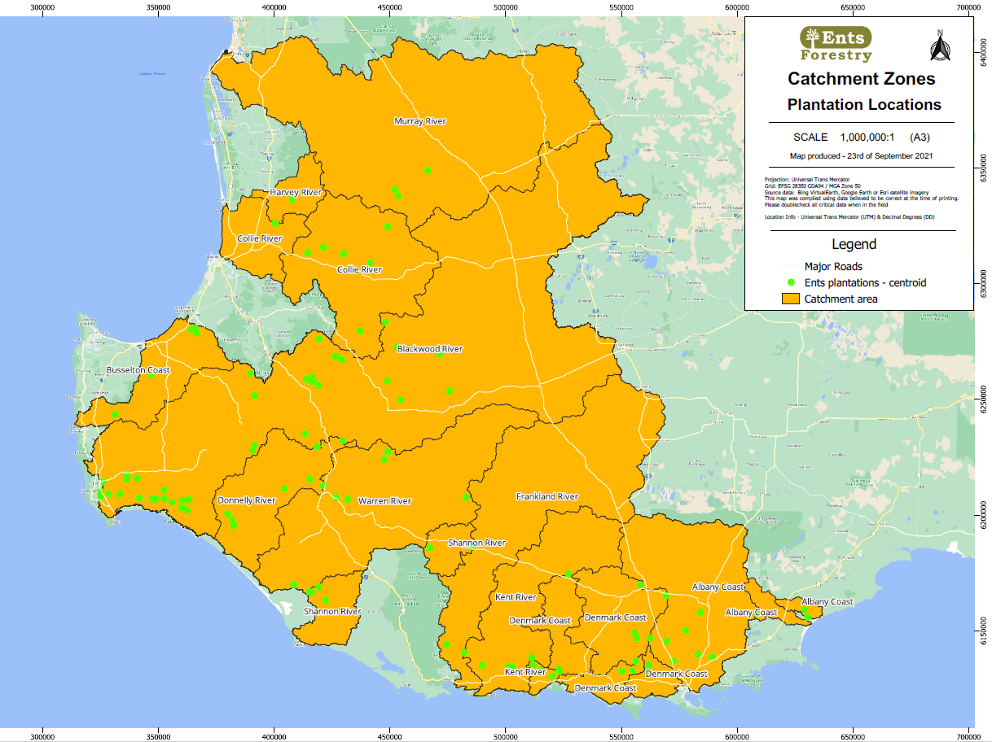
Indigenous cultural values | There are sites in the Ents Forestry plantation which are identified as having cultural significance to indigenous people of the area.  Ents Forestry recognises the aboriginal people as traditional custodians of the land and the significance of heritage, including places, objects and stories. Ents Forestry acknowledges the social, spiritual, historical, scientific or aesthetic perspectives of Aboriginal heritage in the plantation forests and recognises the shared responsibility of conservation. Aboriginal people still live within the southwest of WA but none within the Ents-managed estate. Similarly, the 2020 land claim settlement with the Noongar people is not relevant to the Ents estate.  The principles by which Ents Forestry will manage places of Aboriginal heritage within the plantation forest landscape are summarised below. Using these guidelines, and in collaboration with Aboriginal communities, we will:  - Foster positive and respectful relationships with local Aboriginal communities and relevant statutory bodies and agencies to inform and guide forest planning and management activities  - Identify, protect and manage places of Aboriginal cultural significance in accordance with Aboriginal Heritage Act 1972 (WA) and Aboriginal Heritage Legislation Amendment and Repeal Act 2023.  - Use best endeavours to consult with local knowledge holders regarding impact of operations on cultural areas.  - Ensure appropriate training for staff to gain an awareness of Aboriginal culture and allow for identification of Aboriginal heritage.  In the rare event that damage to the cultural sites occurs because of Ents’ activities, operations are suspended without delay and measures are adopted to prevent further damage, and the damage is mitigated and/or repaired.
European cultural values | Occasionally, European heritage sites are identified in the estate. They are systematically assessed for threats and managed appropriately with advice from experts if required.
Conservation areas | Ents Forestry manages at least 10% of the total estate specifically for conservation values. The following sites comprise pristine or excellent quality native vegetation managed solely for conservation purposes:
 | Ferrari | 1320 ha  Jarrah, marri wandoo forest with heartleaf understorey, situated between Bowelling and Darkan on the eastern edge of the Darling Scarp.
 | Dunmore | 37 ha  This area has a Conservation Notice upon it and will be proactively managed as a protected area.
 | Wandgee | 854 ha  A large area of continuous forest which leads to coastal dunes and beaches.
 | Lorax Grove | 28 ha  Almost 50% of this tree farm is native vegetation. The large areas join and create a valuable wildlife corridor to neighbouring properties.
Forests maintained for conservation purposes are inherently subject to change as nature is constantly changing. An ecosystem must change as the individuals and communities within it evolve and compete for niches and survival. The general principle of Ents forests managed for conservation is to:
- Identify high conservation value forests and threats to the forest
- Manage the threats
- Allow nature to take its course
- Monitor and observe changes
We respect that long-term (climate change) and short-term (fire) disturbance events will change the nature of the forest over time but these are natural parts of the forests life. Our role as conservator is firstly to do no harm (walking through the bush may introduce weeds or dieback or be a safety risk for staff). Secondary to that principle is the nature of ‘maintenance’ and ‘enhancement’, which are subjective terms when dealing with natural systems and essentially relate to managing the threats.
Our most effective conservation measure (for high conservation value forest, rare species and restores and riparian zones) are to exclude all machinery and remove introduced grazing animals.
In the rare event that damage to the conservation areas occurs because of Ents’ activities, operations are suspended without delay and measures are adopted to prevent further damage, and the damage is mitigated and/or repaired.

Socio-economics
The community we work in is important to Ents Forestry. We value being part of the community and supporting local people and businesses. As a locally owned company, local employment and local businesses are a foundation of the approach to running the business.
The forest plantation industry has been assessed as having strong positive social and economic impacts on the area by the report ‘Socio-economic impacts of the forest industry Western Australia, December 2017’ (Schirmer et al, 2017). This report records the:
- The direct value of the industry to SW WA - $649.2 million
- The employment created - 4,570 jobs
- The general positive view in the community of the industry - 76% of residents in the Great Southern and Esperance regions felt the forest industry had positive impacts on local employment.
Ents activities also have negative social impacts for communities in the southwest. Although growing a plantation is a quiet land use with very low chemical used compared to other industries and infrequent road use, at harvest time there is considerable noise and dust generated and the growing plantation becomes a fire hazard later in the rotation.
Ents mitigates these affects by working with shires on rolling 5-year road plans through the Great Southern Timber Roads Operations Group (TROG) group. These plans allow shires to identify roads likely to have high future heavy haulage use to develop infrastructure to balance industry and other shire ratepayers’ road needs, and allow cross-border collaboration where roads continue over shire boundaries. We are members of the Plantation Industry Fire Cooperative, a semi-formal group comprising all plantation managers in SW WA, with a shared aim to assist each other to keep fires small through early detection, rapid response and efficient deployment, regardless of where the fire has started and whose land it is on.
Should the local community suffer because of Ents’ activities, operations are suspended without delay, the matter is investigated and, if found to be at fault, measures are adopted to prevent further damage, and the damage is mitigated and/or repaired.
Where activities are identified as having a positive impact on the community, Ents will endeavour to continue these activities.

Stakeholder engagement
Information derived from social impact evaluations and/or consultation processes with stakeholders has been considered and, where appropriate, addressed in the planning and implementation of forest management activities. This means we:
- Evaluate social impacts (Schirmer study)
- Consult with stakeholders (in person communication with affected stakeholders is always the first means of communication)
The stakeholder groups we will actively involve in our communications include:
- Local community groups
- Neighbours
- Indigenous groups
- Environmental groups
Affected & interested stakeholders | Ents Forestry encourages all interested parties to register as stakeholders. We view stakeholders as an important barometer into the community and value each piece of feedback. We offer regular updates on our activities to any interested group or individual.  Stakeholders can register their interest through our website.

Workplace Health and Safety
Ents Forestry understand the risks involved in working in a forest. To mitigate this risk, comprehensive training and understanding of procedures and use of equipment is required.
Everyone working in the forest is important. Safety rules and regulations apply to everyone equally and need to be implemented in a cooperative fashion.
The responsibility for safety in the workplace is placed on individual workers and managers. Individuals need to be aware of their own safety and the safety of those working with them. Managers need ensure all safety requirements are followed at all times.
We encourage reporting of incidents and near misses. This allows us to focus on areas we believe may be the highest risk.

Forest operations and support functions
Planning |  | Planning each stage of operations for a plantation will lead to outcomes that maximise returns and limit negative outcomes for the environment and stakeholders. All planning by Ents Forestry is aligned with legislative requirements and our philosophy of delivering best outcomes. Good planning leads to good decision making.
Silviculture |  | The silvicultural inputs in our forests are matched to the conditions of the forest. Cultivation, seedlings planted per hectare, fertilisation, watercourse and erosion management, control of weeds is appropriate for the attributes of the site which include location, soil type and specific climate. We seek good genetics for our new plantings but strictly do not use Genetically Modified Organisms. No invasive exotic species will be used. Our foresters and contract partners are focused on continuous improvement and innovation to improve our sustainable plantation management. Operations can occur throughout the year although some are more seasonally dependent where related to soil moisture (weed control, fertilising, planting).  This is all detailed in our Silviculture Manual and safe work procedures.
Harvest & logistics |  | Our foresters carefully plan harvest operations to minimise the environmental and social impacts. Haulage routes are planned with road capacity and public safety in mind. Annual harvest rates are scheduled to optimise financial return to growers and maintain a steady woodflow to customers where long-term arrangements are in place.
Pest management |  | We use an integrated approach to pest management based on the complimentary use of non-chemical and chemical application techniques, selectively applied based on a good understanding of pest life cycles and effects on plantations. Our general approach is to leave pests to create a local equilibrium by natural predation among species in the system. Chemical intervention will only be used when the natural system is being overrun with one particular pest.
Fire protection |  | Fire is a serious threat to the forest we manage and to the community. We invest in control measures to protect our staff, our neighbours, our local communities and our plantations from the risk of wildfire.  We facilitate fire insurance for growers and develop plans to mitigate the risk of fires entering or spreading within our estate.
Road construction and maintenance |  | Roads provide a safe path for trucks to transport timber from our forests to our customers' mills and access to our plantations for firefighting and forest operations. We maintain our roads so they will be safe for our activities. We limit the construction of new roads to limit impact on the environment.

Non-timber Products
 | The range of forest products and ecosystem services that could strengthen and diversify the local economy
Introduction | A number of non-timber benefits exist for the local community, environment and individual stakeholders. These are outlined below.
Non-timber forest products | The non-timber forest products in the FMU include:  - Bees  - Water  - Agistment  - Traditional agriculture  - Motorbikes  - Other outdoor pursuits
Bees | Although bluegums often do not flower through a 10-year rotation, apiarists sometimes take advantage of good quality remnant vegetation throughout the FMU to deploy beehives and produce commercial quantities of honey. The arrangement is by mutual agreement of foresters and beekeepers, mindful that some staff are allergic to bees.
Water | Though not monetised, it is widely considered that water quality from plantation catchments is better quality (lower turbidity, lower E coli levels, lower chemical fertiliser levels, lower salinity) than comparable catchments where traditional farming continues.  For example, the Denmark River catchment, slated as a future drinking water source in the 1980s, became too salty for potable water in the 1990s. Salinity levels arrested and then declined substantially in the decades after extensive bluegum plantings were established in the upper catchment.
Agistment | Weed levels under plantations sometimes warrant introduction of grazing animals to reduce the burden. Modest agistment fees are charged to farmers for the mutual benefit of additional grazing and lower weeds and fuel loads under crop trees.
Traditional agriculture | Where freehold land is uneconomical for continuing rotations of timber plantations, the land may be converted back to traditional agriculture purposes such as cereal crops, sheep and cattle.  On freehold sites with undeveloped paddocks, land may be kept for agriculture if the economics or other planning controls dictates. For instance, seed potatoes are grown on existing centre pivots at Scott River and cattle rotated through adjacent paddocks to ensure correct farinaceous tuber pest and disease controls and maintained. Land kept for agriculture may be farmed by Ents or leased to third-parties on a case-by-case basis.
Motorbikes | A third-party commercial motorbike park operator coexists with Ents at one particular farm. The motorbikes are permitted to ride through the forest with multiple controls in place and comprehensive indemnity arrangements covering adverse outcomes. The arrangement is of no commercial benefit to Ents.  On occasions, motorbike ‘enduro’ events have travelled through specific properties, again with strict protocols and insurances in place.  Otherwise, motorbikes are unwelcome in company-managed forests.
Other outdoor pursuits | The FMU is otherwise closed for public recreation unless by special request for individual circumstances at the sole discretion of the property owner and/or Group member.

Property management & security
The Ents Forest estate is private land and public access is not allowed. Where practicable, each forest unit is fenced and signposted with appropriate warnings.
Illegal access to and activities in the forest is reported to authorities.

Research & development
Ents Forestry is an active member of Industry Plantation Management Group (IPMG). The IPMG aims to assist in minimising economic losses due to pests and diseases by sharing information, enhancing collaboration among its members and by conducting research toward the development of environmentally sustainable, economic, and effective methods of managing pests and diseases.
Membership to the IPMG allows Ents Forestry to have access to critical scale research on pests and disease and nutrition issues and how they relate to growth.
Ents is also an active member of Forest & Wood Products Australia (FWPA) –a not-for-profit industry services company - sometimes referred to as an RDC (Rural Research and Development Corporation) - funded by the Federal Government, member levies and research grants. FWPA collaborate with government and industry stakeholders to determine strategy, invest in effective and relevant R&D and deliver programs designed to grow the market for forest and wood products, increase productivity and profitability across the value chain and ensure positive environmental and social outcomes.

Monitoring
The forest estate is continually monitored. Visual inspections for health, growth, infrastructure, possible erosion, water flow issues and unexpected outcomes occur regularly.
Specific monitoring for water quality is completed to look for changes which could result from fertilising or pesticide use.
All identified high conservation values are specifically monitored to ensure negative impacts are not occurring. In conservation areas, monitoring observes natural processes in action at representative sample points. Ents will periodically publicise results from monitoring across its estate.
Plantation forest growth and yield is monitored through routine inventory that is carried out at age 4.5 and 7.5 in the blue gum estate.
Operational impacts are monitored through regular inspections during periods of activity in the forest (silviculture or harvest).

Human matters
We like our fellow humans and are committed to the enduring sanctity and quality of life of all those who enter our forests. We benchmark our safety and human rights processes against the International Labour Organisation conventions and applicable laws. This means that we don’t tolerate modern slavery in any of its forms, celebrate diversity and treat people equally, reward people appropriately for their skills and services and uphold workers’ rights in the workplace.
Our meaningful and measured engagement with affected and interested stakeholders, including local communities and indigenous people within our FMU, is detailed elsewhere in this plan.
If people are unhappy with what we’re doing we provide the means for them to give their grievance a fair hearing through our website.

Corruption
Anti-corruption | We don’t accept bribes or engage in corrupt activities of any kind.  Ents establishes controls to ensure compliance with all applicable anti-bribery and corruption regulations and to ensure that its business is conducted in a socially responsible manner. The central tenets of this are captured in the Anti-bribery and corruption policy and procedure.

Review
 | This Procedure will be reviewed from time to time as and when required to adopt standard developments and changing local stakeholder requirements.

Version | Author | Date | Review reasoning
0.1 | A Wright | 15/03/2021 | First draft
1.0 | S Bourke | 21/10/2021 | Document finalised
2.0 | S Bourke | 16/09/2022 | Annual update
2.1 | A Wright | 13 Sep 2023 | Annual update, including removing Katherine from conservation area.
2.2 | A Wright | 7 Nov 2024 | Annual update
2.3 | A Wright | 14 Oct 2025 | Annual update

Prepared by: | Andy Wright
Reviewed and recommended by: | Andy Wright
Authorised by: | Andy Wright
Issue date: | 14 October 2025
Version #: | 2.3

Appendix 1 - References
 | Schirmer, J., Mylek, M., Magnusson, A., Yabsley, B., and Morison, J. (2017). Socio-economic impacts of the forest industry, Western Australia, December 2017, Forest and Wood Products Australia, Perth.

Appendix 2 - Definitions
Term | Definition
Headwater streams | Permanent, intermittent and ephemeral first order streams (Strahler stream order) with identifiable aquatic habitats. Headwater streams will commonly have distinct banks and riparian zones will be defined as extending from the incised stream banks
Buffer zones | A forested area near a watercourse which helps shade and protect a stream from the impact of adjacent land uses within which soil disturbing management activities and harvesting is excluded
Filter strips | Vegetation alongside a watercourse which helps to slow the flow of runoff water and functions to control sediment movement. Machinery movements are permitted provided they are consistent with the intended function of the filter strip.
Drainage lines | Areas of slope convergence where water naturally concentrates and flows. Drainage lines have an incised channel with defined bed and banks or evidence of active erosion or deposition, e.g. gravel, pebble, rock bed or scour.
Machinery exclusion zones | Area within which no machinery is permitted
Threatened species | Species that meet the IUCN (2001) Criteria for Vulnerable (VU), Endangered (EN) or Critically Endangered (CR), and are facing a high, very high or extremely high risk of extinction in the wild. These categories may be reinterpreted for FSC purposes according to official national classifications (which have legal significance) and to local conditions and population densities (which should affect decisions about appropriate conservation measures).(Source: Based on IUCN. (2001). IUCN Red List Categories and Criteria: Version 3.1. IUCN Species Survival Commission. IUCN. Gland, Switzerland and Cambridge, UK)

